Anthony Torres

Deveshwar Singh

CS 323

Fall 2019 Assignment Writeup

## 1. Running Trials and Tribulations

(a) Describe the optimal substructure/recurrence that would lead to a recursive solution.

At the base case state, the only two cases for the runner are whether they get injured on a day or not. If the runner is injured at a speed, you only need to check the previous speeds with one less day. If the runner is not injured, you would have to check the remaining speeds with the same amount of days.

(b) Code your recursive solution under runTrialsRecur(int possibleSpeeds, int days). If your recursive function runs forever, in order for grading to happen quickly please comment out the code progress you made instead.

Done.

(c) Draw recurrence tree for given (# speeds = 6, # days = 2)

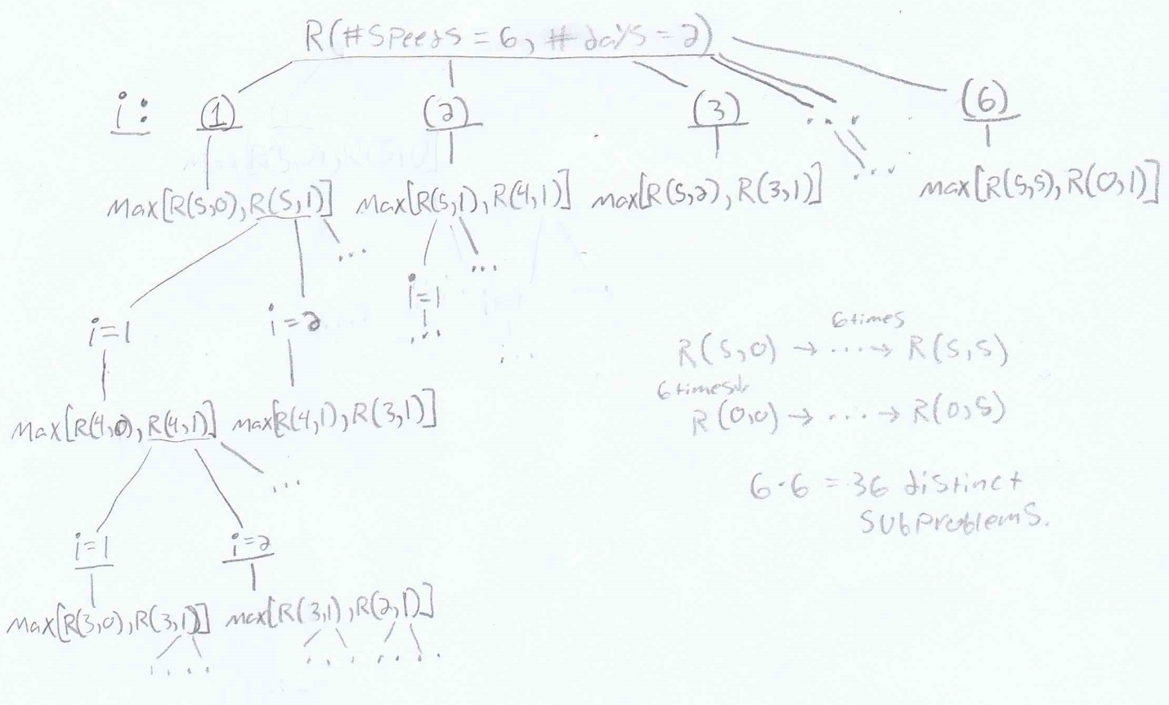

(d) How many distinct subproblems do you end up with given 6 speeds and 2 days?

There would be (6*6) = 36 distinct subproblems.

(e) How many distinct subproblems for N speeds and M days?

There would be (n*n) = n2 distinct subproblems.

(f) Describe how you would memoize runTrialsRecur.

Create a table to store the solutions for each distinct subproblem. When calling the runTrialsRecur function, the table will be searched to see if either the left or right recursive call is stored in the table already. If it is stored then you would only need to look up the table at a constant speed, instead of solving the subproblem again.

(g) Code a dynamic programming bottom-up solution runTrialsBottomUp(int possibleSpeeds, int days)

(h) Extra Credit: 15 pts, write a function that will also print which speeds the athlete should test during those minimum number of speedtest runs, and have it print to the output.

**2. Holiday Special - Putting Shifts Together**

##### (a) Describe the optimal substructure of this problem.

##### The optimal substructure of this problem is to find the most chef with the most back to back steps and choose that chef. After choosing that chef we eliminate the steps he does, you then find the next chef with the most back to back steps that are not done by the previous chefs, adding each chef to the optimal solution.

##### (b) Describe the greedy algorithm in plain words that could find an optimal way to schedule the volunteers for one recipe.

The greedy algorithm that could find an optimal way to schedule the volunteers for one recipe would be to find the chef with the most back to back steps and assign him those steps for that recipe, this eliminating those steps from the open steps. Then find the next chef with the most back to back steps and assign him those steps for the recipe, eliminating those steps from the open steps. Repeat this process until all steps are done.

#### (c) Code your greedy algorithm in the file "HolidaySpecial.java" under the "makeShifts" method where it says "Your code here". Read through the documentation for that method. Note that I've already set up everything necessary for the provided test cases. Do not touch the other methods except possibly adding another test case to the main method. Done.

(d) What is the runtime complexity of your greedy algorithm? Again, you don't need to factor in the setup of the signup table, just your scheduling algorithm.

M = #of cooks

N= # of steps

The runtime complexity of our greedy algorithm is O(M*N) + O(2N). M*N because we have a nested for look that looks at each cook and their steps. Plus 2n because our while would run N times if each step theoretically did 1 step. The last for look would run N if each chef only did 1 step.

(e) In your write-up file, based on your answer to part b, give a full proof that your greedy algorithm returns an optimal solution.

Suppose our algorithm from answer B produces this Solution, and the optimal solution is:

Algo: S1+S2+S3+.…+SN

Opt: W1+W2+W3+….WQ

Let i be the first index where Si and Wi not be equal to each other. By design of our algorithm, S1 should have the longest number of back to back steps. Which means W1<S1. Which means we can replace W1 with S1 to use less chefs. We can use the same argument for Wi+1… WQ.

By the end our modified Opt = Algo. We reach a contradiction that Opt was necessarily more optimal.

## 3. League of Patience

#### (a) Describe an algorithm solution to this problem. Feel free to talk about how you would adapt an algorithm we covered in class.

The algorithm would be something like prims algorithm, but the shortest edge criteria is changed to be abs(next - duration) the edge with the value closest to 0. If there are any ties, it would be chosen off which of the ties has the shortest duration. That result will be the criteria we use for choosing the “shorter edge”.

#### b) What is the complexity of your proposed solution in (a)?

Since our algorithm is a modified prims algorithm. We are using an adjacency matric the complexity of our proposed solution should be O(V^2).

#### (c) See the file LeagueOfPatience.java, the method "genericShortest". Note you can run the LeagueOfPatience.java file and the method will output the solution from that method. Which algorithm is this genericShortest method implementing?

The genericShortest method seems to be implementing prims algorithm.

#### (d) In the file LeagueOfPatience.java, how would you use the existing code to help you implement your algorithm? The existing code only handles one piece of data per edge, so describe some modifications. Note the helper methods available to you, including one that simulates the game's API that returns the next quest time.

We could use the existing code to help us implement our algorithm by modifying the criteria it uses for choosing the next quest. We would modify it so it would account for the waiting time also by doing abs(next - duration), and choosing the quest that is closest to zero. If there is a tie, we choose the quest with the shortest duration.

#### (e) What's the current complexity of "genericShortest" given V vertices and E edges? How would you make the "genericShortest" implementation faster? Describe any algorithm changes or data structure changes. What's the complexity of the optimal implementation?

The complexity of genericShortest is O(V^2). To make it faster we could implement a binary heap and adjacency list to achieve a complexity of O(E(logV)).

## Summary

1. How the work was divided up between individuals/who did what in both coding and write-up:

The first problem’s coding segments and its writeup were done by Anthony Torres. Deveshwar Singh wrote the code needed for problem 2 and its writeup as well. Deveshwar and Anthony worked together solving the subproblems of problem 3. The writeup for problem 3 was done by Deveshwar and the coding segment was done by Anthony.

1. The experience of working together:

Working together helped us focus on our individual tasks without having to worry about the other problems. It saved us a lot of time for the first 2 problems, since we were able to get both those problems solved simultaneously. Working together on problem 3 made the process go by much quicker than it would have gone working on it alone. We bounced ideas and guesses to each other and the process helped us quickly tackle through the subproblems. Working together via GitHub allowed us to merge our forks, and that helped us manage our files and combine our writeups into one document.